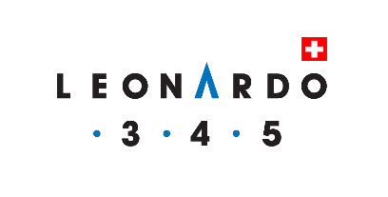

Practical and financial conditions
Training and Accreditation
In the Leonardo3.4.5 methodology

REGISTRATION:
Send your registration in writing; once the deposit is paid the registration will be considered as valid. International Consulting Expertise EEIG will register registrations in the order in which they are received and will confirm their registration to the participants. If the maximum number of participants is reached, participants will be notified of their inclusion on a waiting list.

FINANCES:
The deposit is due upon receipt of the registration; the balance is due at least 21 days before the start of the training seminar to be able to start the blended-learning process.

CANCELLATION:
The deposit is refunded if withdrawal is made before the first learning activity has started; any activity started is due in full.

CERTIFICATES:
Upon successful completion of the exam, a certificate of completion of the course and certification will be issued.

PAYMENTS:
All payments are to be made to the following account with the communication “Leonardo345 Accreditation NAME SURNAME DATE”

BE77 0689 0433 2542

I accept the practical and financial conditions of (insert company name)

Date : ………………………………………..………… Signature : ……………………………………………………………….……………………………………..….

